**Project Design Phase – II**

**Data Flow Diagram and User Stories**

|  |  |
| --- | --- |
| Date | 3 October 2022 |
| Team ID | PNT2022TMID14584 |
| Project Name | Customer Care Registry |
| Maximum Marks | 4 Marks |

Data Flow Diagram:

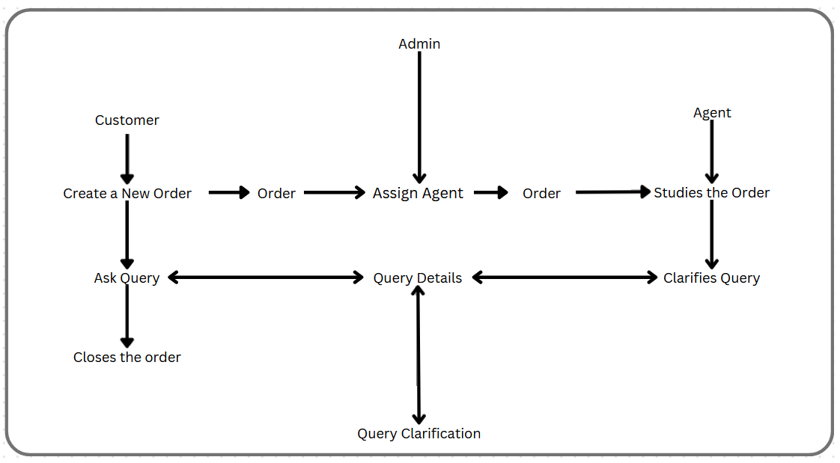

|  |  |  |  |  |  |  |
| --- | --- | --- | --- | --- | --- | --- |
| **User Type** | **Functional Requirement (Epic)** | **User Story NO** | **User Story/ Task** | **Acceptance criteria** | **Priority** | **Release** |
| Customer  (Mobile user) | Registration | USN-1 | As a customer, I can register for the application by entering my email, password, and confirming my password. | I can access my account / dashboard. | High | Sprint-1 |
| Login | USN-2 | As a customer, I can log into the application by entering correct email and password. | I can access my account/ dashboard. | High | Sprint-1 |
| Dashboard | USN-3 | As a customer, I can see all the orders raised by me. | I get all the info needed in my dashboard. | Low | Sprint-2 |
| Order creation | USN-4 | As a customer, I can place my order with the detailed description of my query | I can ask my query | Medium | Sprint-2 |
| Address Column | USN-5 | As a customer I can have conversation with the assigned agent and get my query classified. | My queries are clarified. | High | Sprint-3 |
| Forgot password | USN-6 | As a customer, I can reset my password by this option in case I forgot my old password. | I get access to my account again | Medium | Sprint-4 |
| Order details | USN-7 | As a Customer, I can see the current stats of order. | I get a better understanding | Medium | Sprint-4 |
| Agent -  (web user) | Login | USN-1 | As an agent I can login to the application by entering Correct email and password. | I can access my account / dashboard. | High | Sprint-3 |
| Dashboard | USN-2 | As an agent, I can see the order details assigned to me by admin. | I can see the tickets to which I could answer. | High | Sprint-3 |
| Address column | USN-3 | As an agent, I get to have conversations with the customer and clear his/er doubts | I can clarify the issues. | High | Sprint-3 |
| Forgot password | USN-4 | As an agent I can reset my password by this option in case I forgot my old password. | I get access to my account again. | Medium | Sprint-4 |
| Login | USN-1 | As an admin, I can login to the application by entering Correct email and password | I can access my account/dashboard | High | Sprint-1 |
| Dashboard | USN-2 | As an admin I can see all the orders raised in the entire system and lot more | I can assign agents by seeing those order. | High | Sprint-1 |
| Agent  creation | USN-3 | As an admin I can create an agent for clarifying the customers queries | I can create agents. | High | Sprint-2 |
| Assignment agent | USN-4 | As an admin I can assign an agent for each order created by the customer. | Enable agent to clarify the queries. | High | Sprint-1 |
| Forgot password | USN-5 | As an admin I can reset my password by this option in case I forgot my old password. | I get access to my account. | High | Sprint-1 |